Navigation
URL to develop on: wordpress.sdwatercolor. – we’ll redirect folks that go to sdws.org to this site temporarily.
Navigation
Top Nav: Home | Donate | Workshops | Exhibitions | Calendar

Exhibitions is the only one that will have 2 menu items under it:
- Schedule
- International Exhibition

Calendar needs a plugin that we can fill out manually. Anything close to this is fine.
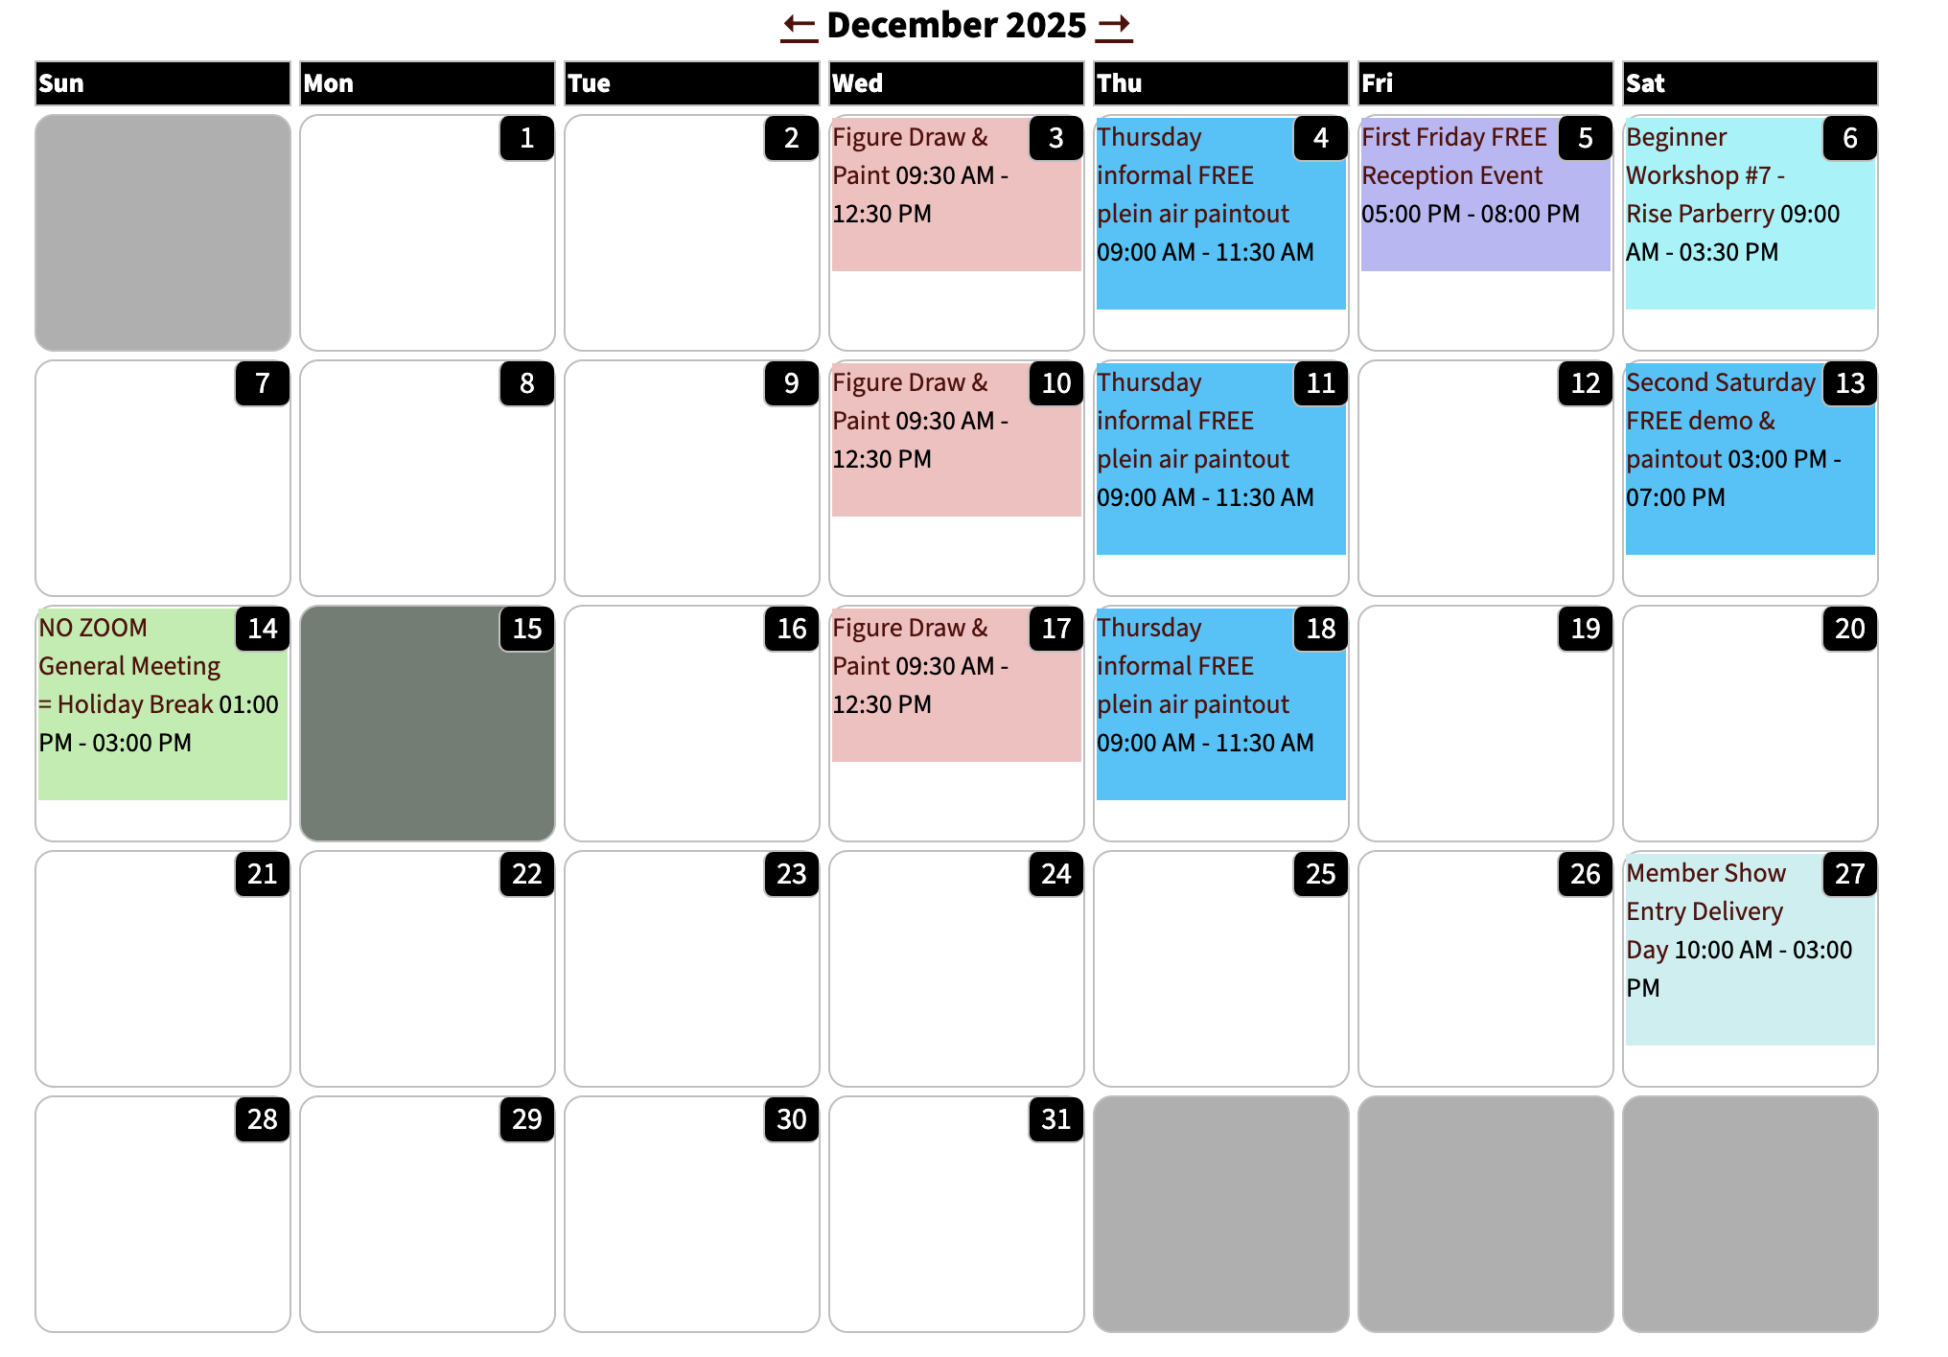

FOOTER
FOOTER
LOCATION
San Diego Watercolor Society
2825 Dewey Rd, Suite 105
Building 202
San Diego, CA 92106
View Map
Privacy Policy (opt out)
Report Website Problems

To contact us, click here to email our support team (mailto: support@sdws.org)

Financial support is provided
by the City of San Diego.
© 2024 San Diego Watercolor Society
SDWS Tax ID Number is 95-3153264

HOME

HOME PAGE
[Text section]
Welcome to the San Diego Watercolor Society! Recently we experienced some technical difficulties on our website. While we are working on updating our backend system, we hope the information provided herein will help keep you up to date on what we’re up to.

[Image gallery]
June Member show

Most likely 90 or so images

[section]
Headline: San Diego Watercolor Society 46th International Exhibition

Body: Taking place Sep 27 - Oct 31, 2026, with over $30,000 in cash and merchandise awards. We’re thrilled to have Juror Ana Laura Salazar judge the competition. Learn more about the show on the International Exhibition page.

[Footer]

Schedule

Current and Upcoming Exhibitions
The San Diego Watercolor Society features a new exhibition each month. Visitors to our gallery can enjoy the latest artwork and vote for their favorite. SDWS Members have the opportunity to enter their artwork.

2026 46th International Exhibition
Show Dates: Sep 27, 2026 - Oct 31, 2026
Juror: Ana Laura Salazar
Online Entry: Feb 1, 2026
Entry day: May 8, 2026
Jury Date: Jun 8, 2026
Reception: Oct 2, 2026
Notes:
Click HERE for the 2026 46th International Exhibition Prospectus Additional Information here: SDWS International Exhibition Page, including the SDWS International Exhibition Framing Requirements

2026 Out N About 10th Annual Plein Air Show
Show Dates: Jul 1, 2026 - Aug 1, 2026
Juror: Ken Goldman
Online Entry: Mar 22, 2026
Entry day: Apr 25, 2026
Jury Date: Jun 30, 2026
Reception: Jul 5, 2026
Notes:

2026 May "Nature's Echo" Member Exhibition
Show Dates: Apr 26, 2026 - May 30, 2026
Juror: Wanda Honeycutt
Online Entry: Apr 15, 2026
Entry day: Apr 25, 2026
Jury Date: Apr 27, 2026
Reception: May 1, 2026
Notes:

2026 June "The Will of the Brush" Member Exhibition
Show Dates: May 31, 2026 - Jun 27, 2026
Juror: Chuck McPhearson
Online Entry: May 20, 2026
Entry day: May 30, 2026
Jury Date: Jun 1, 2026
Reception: Jun 5, 2026
Notes:

2026 July "Patriotic Sagas" Member Exhibition
Show Dates: Jun 28, 2026 - Aug 1, 2026
Juror: Stephanie Goldman
Online Entry: Jun 17, 2026
Entry day: Jun 27, 2026
Jury Date: Jun 29, 2026
Reception: Jul 3, 2026
Notes:

2026 August "Figuratively Speaking" Member Exhibition
Show Dates: Aug 2, 2026 - Sep 12, 2026
Juror: Drew Bandish
Online Entry: Jul 22, 2026
Entry day: Aug 1, 2026
Jury Date: Aug 3, 2026
Reception: Aug 7, 2026
Notes:

2026 September "Urban Rythms" VIRTUAL Member Exhibition
Show Dates: Aug 30, 2026 - Sep 30, 2026
Juror: Lisa Wang
Online Entry: Aug 19, 2026
Entry day: Aug 29, 2026
Jury Date: Aug 31, 2026
Reception: Sep 4, 2026
Notes:

2026 November "Wild Wonders" Member Exhibition
Show Dates: Nov 1, 2026 - Nov 28, 2026
Juror: Roberta Dyer
Online Entry: Oct 21, 2026
Entry day: Oct 31, 2026
Jury Date: Nov 2, 2026
Reception: Nov 6, 2026
Notes:

2026 December "Illuminations and Reflections" Member Exhibition
Show Dates: Nov 29, 2026 - Dec 26, 2026
Juror: Risa Parberry
Online Entry: Nov 18, 2026
Entry day: Nov 28, 2026
Jury Date: Nov 30, 2026
Reception: Dec 4, 2026
Notes:

International Exhibition

San Diego Watercolor Society International Exhibition
Thank you for considering entering the San Diego Watercolor Society’s 46th International Exhibition.
SDWS was established in 1965 and is one of the largest and most active in the United States. The International Exhibition is widely recognized for its high standard of excellence in water media art.
For over four decades, the International Exhibition has been an annual highlight for SDWS. The event attracts entries from hundreds of water media artists worldwide.
The Exhibition features over $25,000+ in cash and awards.
The International Show is the best-selling show of the year!
Learn about our Signature & Master Artist Membership Policy - accepted I-Show artists accrue eligibility (3 - Signature, 10 - Master Artist)
- 46th International Exhibition OJS CFE Instructions
- 2026 SDWS 46th International Exhibition Prospectus

2026 Prospectus
It is crucial to read the entire Prospectus prior to entering. The International Exhibition Standards Committee reviews all accepted paintings for compliance. Failed paintings lead to disqualification, without refund.
All eligibility requirements including the allowed media, substrates, dates, and other important information are described in the Prospectus.
San Diego Watercolor Society Members should take note that these requirements are different from a monthly member show.
Click HERE for the 2026 46th International Exhibition Prospectus

Key Dates
Feb 1: CALL FOR ENTRY OPENS
May 8: CALL FOR ENTRY DEADLINE: May 8, 2025, 11:59 PM Pacific Time
Jun 8: ACCEPTANCE NOTIFICATIONS
Jul 13-24: SHIPPED PAINTINGS TO BE FRAMED DUE TO FRAMER
Jul 20-24: READY-TO-HANG SHIPPED PAINTINGS DUE TO ARTWORKS (SHIPPER)
Aug 1-2: HAND-DELIVERED PAINTING DELIVERY TO SDWS GALLERY
Sep 26: FIRST LOOK/ARTIST GALA & AWARDS CEREMONY (INVITE ONLY)
Sep 27: ARTIST BREAKFAST (INVITE ONLY)
Sep 27 - Oct 31: EXHIBITION OPEN 11AM - 3PM daily
Oct 2: FIRST FRIDAY PUBLIC OPENING RECEPTION
Juror Ana Laura Salazar
Master Artist, Ana Laura Salazar comes from a family of artists, inheriting her talent from her mother, Martha Orozco. Her artistic training, complemented by various workshops, prepared her to excel in the field of painting, particularly in the watercolor technique. She has been a member of the Mexican Society of Watercolorists since 1987. Throughout her career, she has showcased her work in numerous solo and group exhibitions in Mexico, Bulgaria, India, China and the US. Her paintings have earned national and international awards. Notably, receiving the Premio Tlacuilo multiple times at the National Watercolor Salon, organized by the National Watercolor Museum in Mexico City, as well as the Premio Tláloc, awarded by the Watercolor Museum of the State of Mexico.
Internationally, she has achieved significant recognition, including serving as a juror of the III International Youth Watercolor Festival held in Plovdiv, Bulgaria in 2025, being invited as a judge for the 2nd Kipus Bolivia Exhibition in 2024, being invited to 1st Qingdao International Watercolor Festival held in China in 2023, and winning first place in the San Diego Watercolor Society (SDWS) International Exhibition for two consecutive years 2018 & 2019.
Ana Laura’s artistic journey reflects a passion for watercolor and a commitment to promoting this technique through her acclaimed paintings and workshops. She is currently fully dedicated to the visual arts, teaching painting techniques in her private studio and is excited to serve as the 2026 SDWS 46th International Exhibition Juror.

Workshops

Workshop Information
Please contact our workshops registrar at registrar@sdws.org if you need assistance or the Workshop Director, Stephanie Van de Wetering, at workshops@sdws.org with any questions.
In-Gallery Workshops: All in-gallery workshops are held in our beautifully light-filled education center inside the San Diego Watercolor Gallery in The ARTS District of Liberty Station at 2825 Dewey Rd, San Diego, CA. (Location)
ZOOM Workshops: Virtual workshops will be conducted using Zoom. They will include a combination of live painting demo(s), interactive communication with the instructor, and individual painting time - all from the convenience of your home studio. Students will be able to download the recordings of the workshop and keep them forever.

Upcoming Workshops

In person at the gallery workshops
[image] Capturing the Moment in Watercolor, Geoff Allen (June 8-10), $300 member/$325 non-member
Keep it lively and spontaneous. Through coastal, landscape, and still-life subjects, you’ll learn techniques for painting with energy and freshness — indoors and outdoors.
[image] Figures Through the Light and Shadow, Eudes Correia (June 21-23), $550 member, $575 non-member
Discover how light and shadow can transform your figure paintings. Join Eudes Correia for an inspiring deep dive into expressive, luminous figures that radiate joy and life.

[image] Reality and Imagination, Ana Laura Salazar (August 10-13), $425 member/$450 non-member
Blend reality with imagination. Learn Ana Laura Salazar’s unique techniques for developing fantastical concepts, whimsical compositions, and magical animal-and-figure subjects.

[image] Line and Watercolor, Lori Mitchell (September 5-6), $165 member/$185 non-member
Combine the strength of line with the beauty of watercolor. Experiment with different materials, limited palettes, and creative compositions to make your paintings pop.

Zoom workshops

[image] Wild Birds in the Spirit of Abstract Realism, , Zoe Evamy (July 18-20), $300 member/$325 non-member
Bring birds to life with a twist in this acrylic workshop.. Paint realistic feathered forms while exploring abstract backgrounds for contrast and impact — all from the comfort of your own studio via Zoom

[image] Florals and Fruit: From Real to Really Amazing, Suzanne Hetzel (November 9-11), $275 member/$300 non-member
Take your florals and still lifes from traditional to extraordinary. Each day, you’ll explore a new technique — from realistic to expressive to abstract — and leave with fresh approaches for vibrant, eye-catching paintings.

Beginner Series Workshops
May 23, 2026 - #6 Beginning Portraiture, Susan Hewitt
June 20, 2026 - #1 Beginner Basics, Jami Wright
Aug 15, 2026 - #2 Color and Value, Julie Anderson
Sep 12, 2026 - #3 Drawing for Watercolor, Julie Anderson
Nov 7, 2026 - #4 Still Life, Susan Hewitt
Nov 21, 2026 - #5 Landscapes, Jami Wright
Dec 12, 2026 - #6 Beginning Portraiture, Susan Hewitt

Download List of Materials

DONATE
DONATE

THANK YOU for considering a donation to the San Diego Watercolor Society.
A gift from you can help SDWS enrich lives through experiencing watermedia painting.
- The free SDWS Gallery offers monthly Member Exhibits, Special Exhibits and the Annual International Exhibition, which attracts hundreds of exceptional artists from all over the world.
- Painting classes are available for elementary school children and adult painters at all skill levels.
- Each week, community residents and SDWS members experience plein air painting at beautiful sites throughout San Diego County.

[ Donate button ]Paypal link https://www.paypal.com/ncp/payment/KSDUHVURSRZSJ

